# DVM1 Horse Handling and Restraint

# Session 3

## Learning outcomes:

At the end of this practical students should:

* Be able to approach a horse and safely pick up a front limb and hind limb of a horse for routine husbandry care

Assumed competencies:

* Demonstrate the correct procedure for safely approaching and releasing a horse
* Be able to catch a horse, fit and secure a halter and lead a horse
* Identify and appropriately use grooming equipment on a horse
* Demonstrate how to correctly apply a horse rug
* Be able to tie a horse to a break away using a quick release knot

### Preparation

For the third horse handling practical class we will continue to work on the skills you have learned in the previous sessions and begin practicing picking up horse limbs. Remember individual horses behave differently so it is important to practice these skills on different horses. Please review the material below prior to attending the practical class.  Throughout these sessions you will complete the same tasks that you did on the simulators but on the live animal.

Watch these videos:

*\*You will not need to place the horse’s leg between your leg for this first attempt at picking up feet. Practice picking up the foot and cleaning it with a hoof pick.*

Picking up a forelimb- <https://echo360.net.au/media/5c823cf5-0397-4efc-a718-20cef1f70634/public>

Picking up a hindlimb- <https://echo360.net.au/media/0c53680c-c8d1-4495-8da5-54e45bd74c3a/public>

Most horses have their feet picked up and cleaned out daily as a routine husbandry procedure and veterinarians must handle limbs as part of their lameness examinations. To do it safely, the handler must be familiar with picking up and holding the legs of a horse.

**Note: To complete this procedure you must have a handler holding the horse, standing on the same side as you. If the horse misbehaves, the handler can pull the horse towards themself and/or push the horse away from the person working on the horse feet.**

### Picking up a forelimb

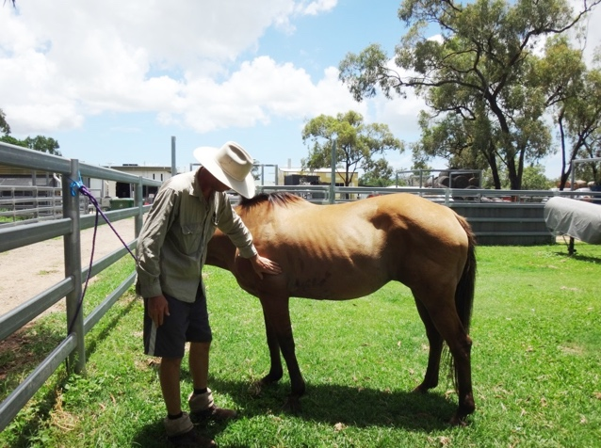

To lift the foreleg, approach the horse at the shoulder from a 45° angle, facing towards the tail of the horse.

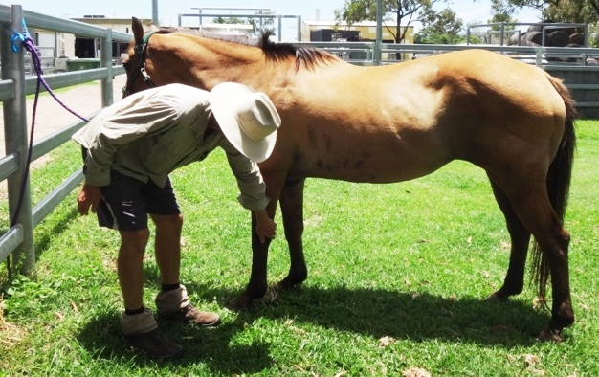

Run your hand down the rear of the horse foreleg, over the elbow, back of the knee down the cannon bone to the fetlock. Lean slightly into the horse’s shoulder with your shoulder.

When the horse lifts up his foot, be sure to hold the hoof and not the fetlock or pastern joint because the latter can make the horse uncomfortable.

*To clean the hooves, you can hold the hoof with your left hand and clean the hoof with your right hand. To clean the hoof, move the pick from the heel to the toe.

### Picking up a hindlimb

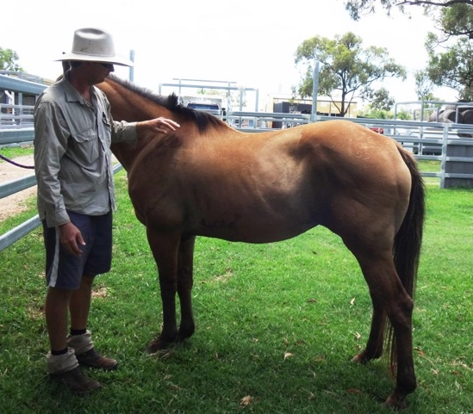

To lift the rear foot, approach the horse at the shoulder from a 45° angle, facing towards the tail of the horse

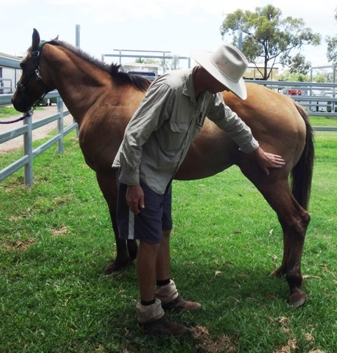

Run your hand over the horse’s back, rump and down the horse’s rear leg to the back of the fetlock.

When the horse lifts up its leg; move forward slightly (to the back of the horse) to hold the foot with you inside hand and clean the hoof using a hoof pick with your outside hand.

Grasp the fetlock and pull the limb up and forwards keeping your hand on the outside of the limb at all times.